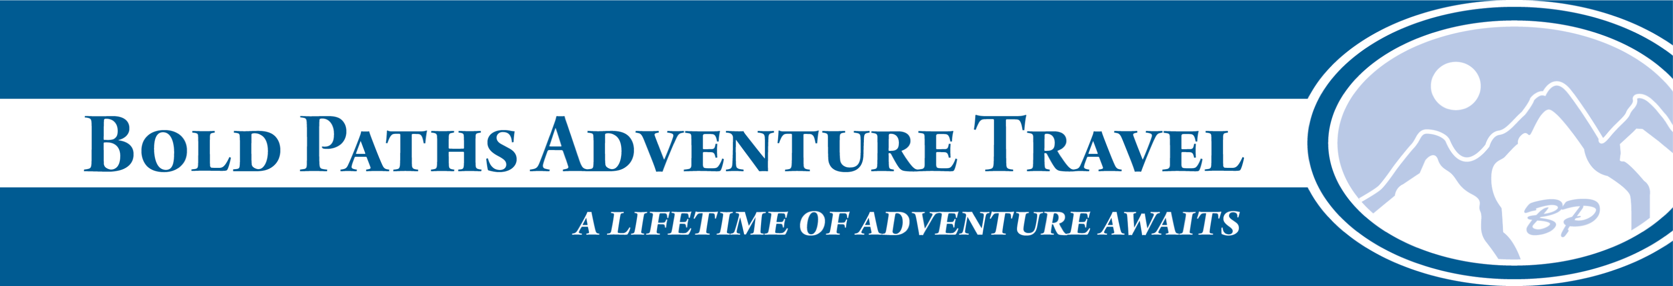
www.boldpaths.com info@boldpaths.com 802--333--3549
Sept 16-17, 2017 Women's 9th annual kayak trip on the Connecticut River
We paddle on flat gently moving waters, delightful for a relaxing paddle or to stretch your muscles. We can provide shorter amounts of paddling for those who want it, or longer stretches of the river for those who want to paddle further. Kayak rentals are available, with paddle, pfd and dry bag.
Accommodations: Folks may stay at the Breakfast on the Connecticut B&B’s main house (It is the only B&B on the entire Connecticut River, and is lovely, right on the water). For this option, you make your own reservations directly with Breakfast on the Connecticut, Lyme NH 03768. 603-353-4444. http://breakfastonthect.com/ You can also commute from home, or overnight at my place, either indoors or on the tent platforms (one has a 6 person luxury tent, the other a tarp covering and we can put smaller tents on it). Join us for one day or two days of paddling, or half-days if you prefer. If you come from afar, we are happy to meet you at local public transportation, or help you with carpooling.
If you stay at the Breakfast on the Connecticut on Friday night, we can all meet there with goodies for a pre-trip rendezvous. Please make your own reservations there.
Paddling: If anyone wants to take the upper leg from Bradford to Orford 9 miles, we can guide and support your trip on Friday Sept 15th, then join the rest of the journey with the larger group who chooses to start in Orford on Saturday afternoon.
Paddlers can choose any length trip: *Friday: 9 miles Bradford to Orford, Lunch in Orford. *Saturday 6 miles Orford to B&B in Lyme, or 15 miles full trip. Campfire Dinner at B&B *Sunday: 5 ½ miles B&B to lunch in Lyme, or 8 miles to Thetford.
Details: Friday: optional: meet at Breakfast on the Connecticut in Lyme NH. Shuttle boats to starting point at Bradford’s Bugbee Landing boat launch (also primitive campsite). We leave a car at the B&B for the return drive that night to pick up the cars in which we get there. 9 miles to Orford Boat Launch. Saturday: meet at B&B, Shuttle boats to Orford Boat Launch, Dinner at B&B: campfire dinner if weather permits, or we may eat out (individuals’ cost). Relaxing evening together.

Sunday: launch from the B&B, paddle 5 ½ miles to Lyme Hewes Brook boat launch for lunch. You may take out there or continue downriver 3 miles more to Thetford launch. We will pre-set the location of cars.
Costs: $180 for both days. $125/Saturday, $70 / Sunday, plus share of food costs, includes 2 lovely lunches on the river, all snacks, campfire dinner Saturday night. Also included is shuttling and kayak instruction. Kayak rentals at $25/day special rate = $50 for two days rental, with pfd, paddle, boat, instruction and paddling tips.
Deposit: 1/2 of your costs
Contact <boldpaths@gmail.com> for more details and to reserve your spot. All equipment is provided, but you may bring your own boat as you wish.

See you on the river!
Please share with whomever you think may be interested, and share on fb too!
Bonna Wieler
Bold Paths Adventure
www.boldpaths.com
802-333-3549
802-274-0810 cell

